**Bpod helper GUI user manual**:

*currently only windows OS supported

1. Download ‘bpod_helper.fig’, ‘bpod_helper.m’ and ‘Gui.m’ to your computer.
   * Make sure that the path to those files is in MATLAB’s path.
   * Make sure you have **Instrument Control Toolbox** installed
2. Change the following lines in ‘bpod_helper.m’ code to match the path to your data folders:
   * Line 61: path to the folder where you intend to save ‘animals’ files (i.e. a table with the RFID tags and the corresponding names of the mice in the cage).
   * Line 62: path to Bpod protocols (Bpod default is …. Documents\Bpod Local\Protocols)
   * Line 63: path to the folder where you intend to save experiment settings.
   * Line 73: the RFID code of a tester tag, change gui.data.TESTER_RFID

It is advised to dedicate an RFID tag for manual testing of the experiment. It is automatically added to every list of tags of mice currently participating in the experiment, is named ‘0’, and receives the default settings. Every faulty or unrecognized read will be treated as the tester and will appear in the data as related to the tester.

1. Identify how the RFID is recognized by your PC (i.e. what is its COM number):
   * Open windows device manager, expand the ‘Ports (COM&LTP) ’ tab.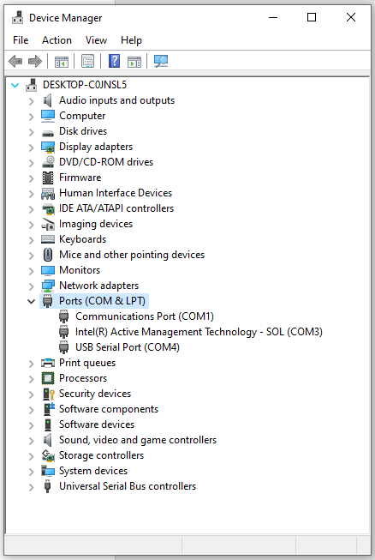
   * Look for a USB Serial Port. (To make sure you identified the one dedicated to your RFID reader, eject its cable and make sure the relevant COM is no longer presented). In this example, (where only an RFID is connected) the COM number of the RFID is ‘COM4’ 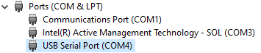
2. Run ‘bpod_helper.m’, the GUI will open.
3. In order to start an experiment, first register the mice currently participating in the experiment to the automate cage, by choosing the ‘create new animals’ tab. 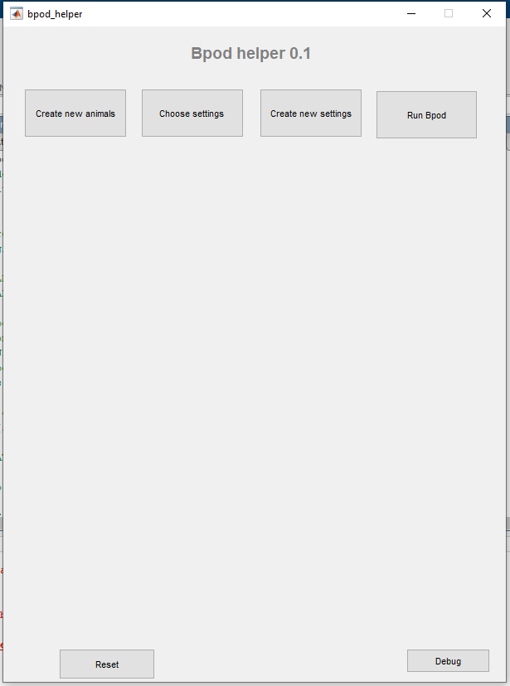

* If you are asked to provide the RFID COM number, enter it as identified in section 3.

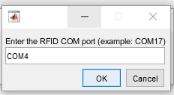

* Make sure the Bpod console is not open

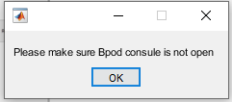

* Scan the RFID of the mice one by one, hold the mouse and position the RFID close to its back where the tag is implanted. Once you are ready to scan a mouse hit the ‘Add new animal’ tab. Once a tag read was detected the GUI will ask you to approve the read. Make sure the RFID number is OK, and not a residual of previous reads that was buffered from the reader.

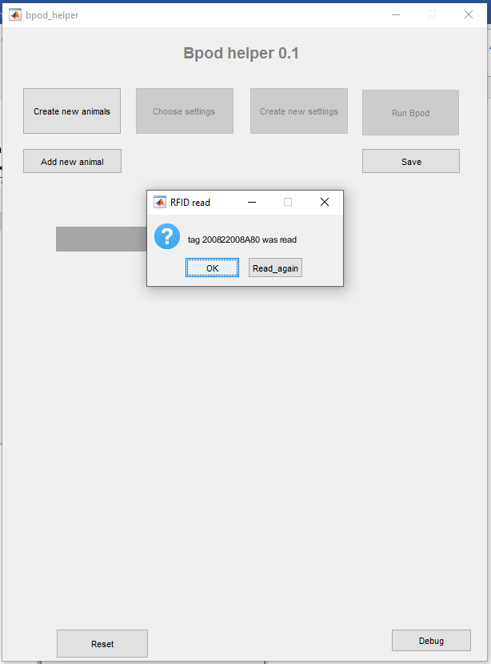

If the read is OK, name the current mouse, and continue to the next one. If not, or if it took too long to try and scan the mouse, read again. 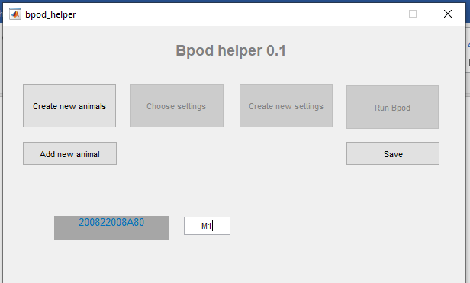

You will end up with a list of tags and the corresponding names.

* Save the ‘animals’ list by hitting the ‘save’ button. The default path for saving would be the one inserted in line 61 (section 2)

1. Create settings file for individual mice. For each protocol there are different parameters that could be changed. In our provided FR protocol, the ratio for rewards (the number of pokes), and the reward size (in ul) can be controlled.

* If you wish to design your own protocol and use the Bpod helper to control a group housed experiment, create a default settings structure and save it under the name ‘…/settings/template.mat’ in the protocol folder.
* If the Bpod helper was already open you can hit the ‘Reset’ button, and then hit the ‘create new settings’ tab.
* Choose protocol from the protocols list (folders in the path set in line 62, section 2), you will be provided the option to insert the settings of interest. Save the created settings by hitting the ‘save’ button
* There is an option to load existing settings file to examine and modify it.

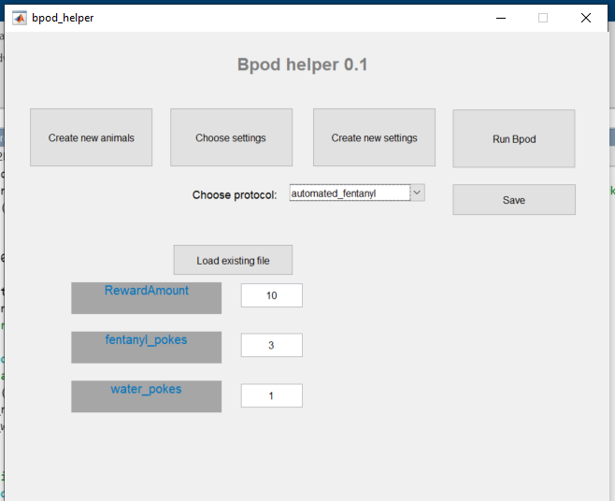

1. Choose settings for the individual animals. Choose protocol from the protocols list (same as in section 6), choose animals file (created in section 5).
   * For each mouse choose a settings file (created in section 6). Mice can share the same settings or have differential settings according to the experimental design. Save the settings under the folder where you intend to save the data from the experiment. (….animals_name/protocol_name/setings_file)
   * There is an option to load existing table of setting Assignment per mouse in the cage to examine and modify it.

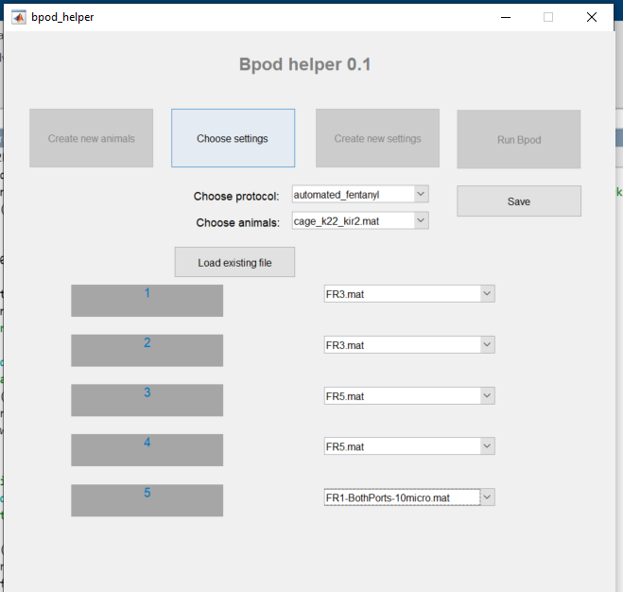

1. Now you can run the experiment from Bpod console. Choose your protocol, choose a subject name that corresponds to your cage name, and choose the table of settings per mouse as your settings file. If Bpod doesn’t recognize your settings table file, brows to import it from the saved location (the import button in Bpod console is marked in red in the screenshot below).

